A Predictive Model for Automatic Generation Control in Smart grids using Artificial Neural Networks
Chika Yinka-Banjo & Ogban-Asuquo Ugot
Department of Computer Science
Univerisity of Lagos
Abstract. The frequency deviation of an electric power system is a key parameter required for evaluating the changes in the load on the system. Frequency deviations are usually due to a decrease or an increase in the system load at any point in time. A substantial frequency deviation implies that the system power generation mismatches the system load, the Automatic Generation Control (AGC) System provides an efficient means through which the load-generation mismatch can be reduced to a minimum. We present a predictive regression model for the AGC capable of forecasting efficiently, the total load on the system in the next minute. The model is a deep neural network trained on multivariate time-series energy consumption data collected for 47 months. Our predictive model and its design is discussed within the context of the smart grid architecture.
Keywords: Smart grid, Artificial intelligence, Artificial Neural Networks, Deep Learning
1 Introduction
The smart grid power system relies on information technology for the implementation of a system architecture where the major electrical components communicate over an IP network. A typical smart grid architecture consists of generation, transmission, distribution and end user nodes [1]. Each of these components may communicate with each other with a goal of optimizing system performance and reducing risk. In a smart grid power system, one can envision a system design where the end user node through electronic components such as smart meters and smart appliances relays data about energy consumption and load patterns back to the dispatch center. The data is used for instance to initiate load distribution, just in time to avoid blackouts caused by overloading the system and will save cost due to damage of equipment.
The operational performance of conventional subsystems found in current power grids, such as the Automatic Generation Control (AGC) already benefit from having some form of feedback about the system load [3], [4]. When there is a change in system frequency with respect to an increase or decrease in load, the AGC, based on the corresponding frequency deviation sends control signals to the generator unit to either increase generation or reduce generation to achieve a balance between the system load and system generation. This balance is not always easy to achieve, with sudden peaks in system load, the AGC gives up control to an emergency control relying on end user load balancing. Over the past decade, researchers have approached the problem of AGC through control strategies such as optimal control theory [16], proportional-integral [17] and proportional-integral-derivative [18]. Optimization techniques such as the multi-objective optimization problem (MOP) [19] and the firefly algorithm together with pattern search optimization techniques [20] have been suggested using PID controllers. The literature survey reveals that in general, the AGC problem has been modelled around controller structure and optimization techniques.
We approach the problem from a relatively different perspective, we observe the direct relationship between the load on the system and the frequency deviation, a key parameter for the AGC. Therefore the ability for AGC system to forecast the load in the nearest future might serve a huge advantage and solve the problem of handling surprise spikes in load. We propose a neural network based predictive model for the AGC, trained on real energy consumption data that serves the purpose of forecasting the load on the power grid in the next few seconds. Our system design, couples this predictive model to the AGC and the output from the model serves as a parameter for calculating and thus forecasting frequency deviation as well. Section 2 lays the theoretical foundations for the proposed system design, in section 3 we present the architecture of the predictive model, the dataset and we report the model performance.

2 The Smart Grid and Automatic Generation Control
The smart grid is an electricity supply network that relies on digital technology for efficient power generation, transmission, distribution and consumption. The smart grid is a proposed improvement upon conventional electric grid systems but the architecture still includes major components such as generators, high tension transmission cables and transformers. In addition to these standard electrical components, the smart grid includes a variety of operational and energy components such as smart meters, smart appliances and efficient energy resources.
Although still theoretical for the most part, many can agree that current and proposed smart grid systems are highly reliable and efficient [2]. Other features of the smart grid include;
- Flexible network topology: the smart grid architecture has been shown to allow bidirectional energy flow, where the grid can generate energy sources as well receive energy from other sources [12].
- Load balancing/ adjustment: the total load on a grid varies highly and is dependent on variables with high uncertainty. When the load on the grid indicates a spike in demand it is essential to redistribute the load or to call on standby generators to support the increase in demand. Smart grid can solve this problem with real-time communication with appliances to efficiently redistribute the load [13].
- Demand response support: Demand response support allows generators and loads to interact in an automated fashion in real time, coordinating demand to flatten spikes. Eliminating the fraction of demand that occurs in these spikes eliminates the cost of adding reserve generators, cuts wear and tear and extends the life of equipment, and allows users to cut their energy bills by telling low priority devices to use energy only when it is cheapest [14].
- Sustainability: the improved flexibility of the smart grid allows for the implementation of more renewable sources of energy. This is due to fact that the smart grid architecture allows for a more distributed feed-in networks.
2.1 Smart Grid Architecture
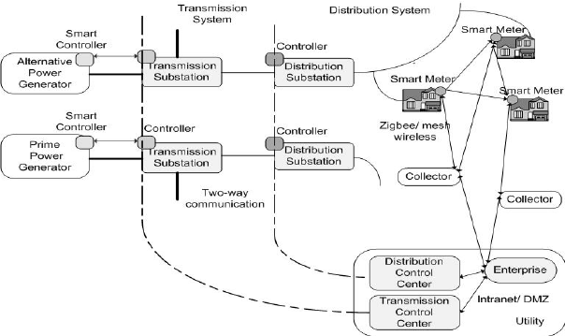
Fig. 1. Typical smart grid architecture [1].

The main components of a Smart Grid (Figure 1) are electric power controllers, smart meters, collector nodes, distribution and transmission control generators, electric power substations, transmission and distribution lines, and control centers [6]. Power generators and electric power substations use electronic controllers to control the generation and the flow of electric power.
End consumers and collector nodes may communicate through a Zigbee or similar mesh wireless two-way communication network [1]. Two-way communication paths are also used between collectors and the utility. Collector nodes communicate with the utility mostly using the Advanced Metering Infrastructure (AMI) [1], [7] possibly via the Internet. Communication between the transmission and distribution substations and the control center guide the operational process. Like existing power grids, a Smart Grid includes a control system that accommodates intelligent monitoring mechanisms and keeps track of all electric power flowing in a more detailed and flexible way [1]. The fact that as a system, the smart grid relies heavily on information technology makes it more suitable to implement modern innovative solutions that can benefit from data and can exist as a software component embedded within any smart grid electronic component.
2.3 Security and Reliability Standards and Requirements
In this section, we shall briefly consider some security concerns and reliability standards required for the implementation of a smart gird. In order for a region to fully enjoy the potential benefits of a smart grid, the system must run on an IP based (open) network [1]. This is an obvious requirement if communication between end user devices and control centers or even amongst all major components of the smart grid is to be guaranteed.
The exposure of Supervisory Control and Data Acquisition systems (SCADA) in such an open network introduces security risks, and thus the protection of these systems is a major concern [8]. Let us consider some organizational bodies that have been set up to ensure that security and reliability standards of the smart grid are met. Taking the USA as a case study, the National Institute of Standards and Technology (NIST), Cyber Security Coordination Task Group (CSCTG) ensure consistency and play an important role in shaping smart grid cyber security research [1]. Another important body is the Federal Energy Regulatory Commission (FERC) [10] responsible for protecting the reliability of the high voltage transmission system. Reliability standards were developed by the North American Electric Reliability Corporation (NERC) [11]. These standards specify the minimum requirements to support the reliability of the electrical systems. The NERC Critical Infrastructure Protection (CIP) standards [13], address the issues concerning cyber security in the power grid.
The importance of cyber security especially for SCADA systems in the smart grid cannot be over emphasized, and thus it is extremely important for other nations especially those who are yet to commence solid research in smart grid technology to set up organizations like the CSCTG and NERC to ensure security and reliability standards. The awareness of the importance of cyber security is observed in Africa too. According to the Global cyber security index in 2017, released by the International Telecommunications Union (ITU) [5], African nations Mauritius and Egypt rank 6 and 14 respectively in legal and technical areas while Rwanda ranks 36 with high scores in standalone cyber security policy. These nations as well as others on the index are already on the right path in terms of establishing proper cyber security standards and reliability as it concerns the smart grid.

2.4 Automatic Generation Control

The electric power system, throughout its life cycle, will exists in any of the following four states; normal, preventive, emergency and restorative [4]. These states describe the operational performance of the system with respect to the frequency deviation and the voltage deviation. The normal state is the desirable state where there is a balance between the load and generation [4].
The goal of the control unit in the power system is to keep the system in a normal state. In any case, it is more than likely that contingencies will arise causing frequency deviation and voltage deviations. One of the most common problems is an overload on the power system, resulting in a mismatch between load and generation. Automatic generation control provides an effective mechanism through which the power system can actively balance power by controlling generation to match the load. In a smart grid power system, the AGC is implemented as a software component [3], and is responsible for adjusting the power system generation to minimize frequency deviation.
The AGC achieves generation control by sending signals to control units for the generator. The performance of the AGC system is dependent on how quickly generating units respond to these signals. In general, we can outline the function of the AGC into;
- Matching an area’s generation to it’s a load and to control the system frequency
- Distribute changing loads among available generators so as to minimize costs.

The first function is achieved by secondary control of the generators to minimize frequency deviation. The frequency of the system is the nominal frequency (usually 50Hz) of oscillations of the alternating current (AC) being generated by the power system. The system frequency rises when the load decreases and may drop if the load increases. However, it is desirable to keep the frequency constant such that$∆f=0$. The power-frequency relation for turbine-governor control [3] is;

$∆p_{m}= ∆p_{ref}-\frac{1}{R}×∆f$ (1)

Where $∆p_{m}$ is the change in turbine mechanical power output, $∆p_{ref}$ is the change in a reference power setting, $R= -\frac{∆f}{∆p_{m}}=-slope$ is the regulation constant which quantifies the sensitivity of the generator to a change in frequency and $∆f$ is the change in frequency. The first function is also achieved in mutli-area power grid, where each area is connected through a tie-line, by means of load-frequency control (LFC) in which the tie-line power is used. The Area Control Error (ACE) provides each area with an approximate knowledge of the load change and is defined as;

$ACE= ∆p_{TL}-β∆f$ (2)

Where $∆p_{TL}$ is the tie-line power deviation, $β$is the frequency bias constant and $∆f$ is the frequency deviation, the ACE serves as feedback for the secondary control [4].
The second function is achieved by distributing the load among different unit generators so as to minimize cost of operation and is based on economic dispatch calculation [3].
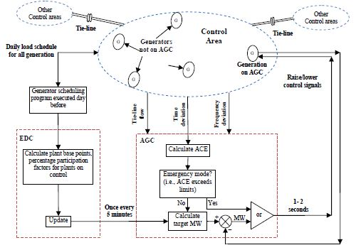

Fig. 2. Typical block diagram for the Automatic Generation Control. The AGC receives input signals including the frequency deviation. The input signals are used to calculate the area control error ACE, and thus determine the control signals needed to return the utility back to the normal state [4].

2.4.1 Frequency Deviations and Associated Controls

The nominal frequency for a typical power system utility is about 50Hz, with some countries running utility at about 60Hz. The frequency deviation $∆f$ is a direct indication of the current changes in utility frequency and says something important about the change in the total load on the utility. The frequency deviation in equations (1) and (2) is a crucial variable required for the AGC as shown in figure 2, and determines the control signals required to control the generators. The frequency deviation is given by;

$∆f=-\frac{∆p_{m}}{β}$, (3)

The symbol $∆p_{m}$ is known as the change in turbine mechanical power, but is actually a ratio of the per unit change in load,$β$ remains the frequency bias constant. For example, if the load on a utility drops by 250MW, and previously, the generators where running on a base load of 500MW per unit generator. Then, the unit change in load $∆p_{m}$is$\frac{-250}{500}= -0.5$. Take note that the numerator is $-250$ because there was a drop in the load. From this, using equation (3), and a frequency bias constant $β$ of 63.2 per unit, the frequency deviation is given as$-\frac{(-0.5)}{63.2}=0.0079 per unit$. We then multiply this by 50Hz to get the frequency deviation in Hertz$∆f=0.0079 ×50=0.3956Hz$. The purpose of this rather incompletely defined example is to demonstrate symbolically the relationship between the change in load and the frequency deviation, the reader may refer to [15] for a complete example on frequency deviation. The value of $∆f$is fed to the AGC and directly influences the type of control signal sent to the utility controllers. The frequency deviation and the corresponding control signal [4] is shown in the table below.
Table 1. Frequency deviation and associated operating controls.
Range of frequency ($f$) | Range of frequency at 50Hz | Types of operation | Types of Control
$f^{0}-\frac{∆f_{1}}{2}$ to  $f^{0}+\frac{∆f_{1}}{2}$ | 50.05 to 49.95 | Normal | No controller is required
$f^{0}-\frac{∆f_{2}}{2}$ to  $f^{0}+\frac{∆f_{2}}{2}$ | 50.20 to 50.05 and  49.8 to 49.95 | Normal operation | Primary control
$f^{0}-\frac{∆f_{3}}{2}$ to  $f^{0}+\frac{∆f_{3}}{2}$ | 50.20 to 51.00 and  49.80 to 49.00 | Off-Normal operation | Secondary Control (AGC)
$f^{0}-\frac{∆f_{4}}{2}$ to  $f^{0}+\frac{∆f_{4}}{2}$ | Above 51.00 and  Below 49.00 | Emergency Operation | Emergency Control

3 Proposed System Design
The success of the AGC is guaranteed only when the frequency deviation is still within the range of $49Hz≤f≤51Hz$ as shown in the table 1. When the frequency and thus the frequency deviation is suddenly increased or decreased beyond that range, the utility is at the risk of a blackout and a resulting damage in equipment costing millions. The problem with current models of the power system and the AGC is that the control systems cannot deal with the non-linearity of the load patterns on a utility. The load on a utility at given point in time is subject to fluctuations that are difficult to predict. Based on this problem, we present a predictive model for the automatic generation control. At the heart of our design is the regression model, in the form of an artificial neural network (ANN) trained on electric consumption data (i.e. the load) collected over 47 months. The goal is to be able to predict the total base load in the next minute. The predicted load is then used to estimate the frequency deviation, which is then fed to the AGC for processing the output control signals.

3.1 Data analysis and feature engineering

The dataset used for the training is a multivariate time-series dataset collected from a single household over 47 months [21]. The data attributes include the date, time (in minutes), global active power (kW), global reactive power (kW), voltage and sub meter readings 1, 2 and 3. Each of the electrical readings are collected per minute, the result of this a large dataset of 2075259 instances. The date attribute is split into day and month attributes, all attributes except the sub meter readings are used as input attributes. The desired output label for the supervised learning required is the total energy consumption, the total load. Since the total load was missing, we had to derive the output label using the formula;

$Total load=\frac{Global active power ×1000}{60}$ (4)

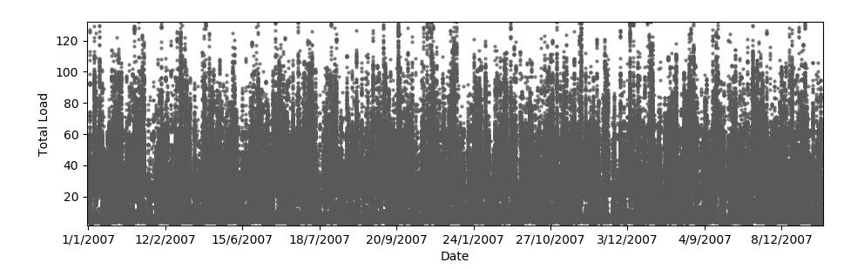
Fig 3. Scatter plot of the total load for just one year. Total load is in Kilowatt.

Due to the fact that the data was collected per minute, the data points are highly dense, we show a scatter plot for the total load for just one week and a day in figure 4 and 5 respectively.
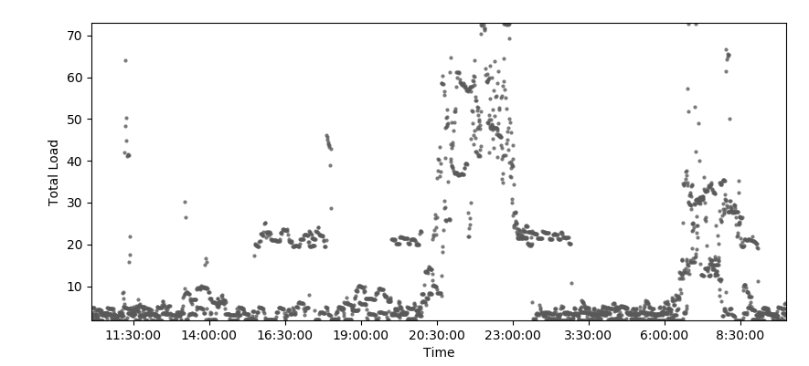
Fig 4. Scatter plot of the total load for one week. Total load is in Kilowatt.

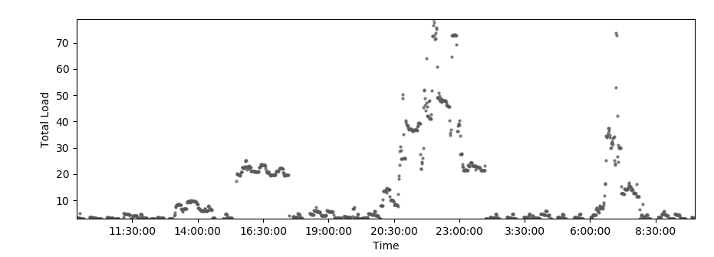
Fig 5. Scatter plot of the total load for one day. Total load is in Kilowatt.

The scatter plots in figure 4 and 5 illustrate the times at which there is a peak load in the system, which is at about 9.30pm. Finally we show a histogram of frequency of total load in kilowatt.
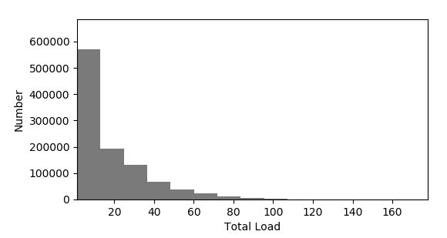
Fig 6. Total load and their frequency.

3.2 ANN architecture

The regression model is a simple model that has two fully connected hidden layers with 7 input attributes. The model is built using the keras deep learning framework and it uses good practices such as the rectifier activation function for the hidden layer. No activation function is used for the output layer because it is a regression model and we are interested in predicting the numerical values directly without transform. The efficient ADAM optimization algorithm is used and a mean squared error (MSE) loss function shown in equation (5) optimized. This will be the same metric used to evaluate the performance of the model. The MSE gives us an error value we can directly understand in the context of the problem.

$MSE=\frac{1}{n}\sum_{i=1}^{n}{{(Y_{i}-\hat{Y_{i}})}^{2}}$ (5)

3.3 Training & validation

The training data contains a sample of 21,992 instances spread over the period of 2006 to 2007.
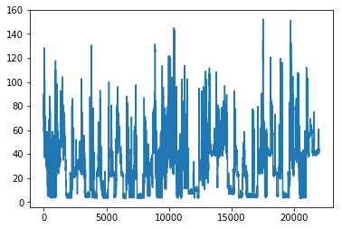
Fig 7. Scatter plot showing output label y in training set.

The kfold cross validation technique is used for training and validating the model. A batch size of 10 and epochs of 100 was used for cross validation scoring. The mean square cross validated score is shown below.

Table 1. Mean square error for cross validated scoring.
Mean square error (MSE) | Mean absolute error (MAE)
$$0.0014$$ | 0.0121
4 Result
The model is tested on an isolated test data from the period between 2008 and 2009, a sample size of 18,100 is used for testing.

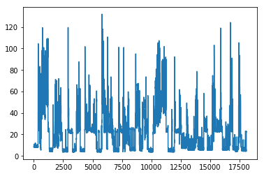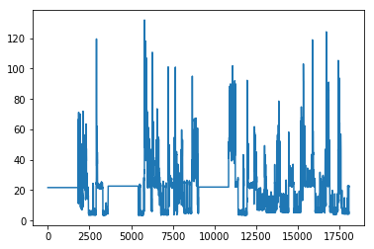
- (b)

Fig 8. (a) Scatter plot for test data output label (b) Scatter plot showing predicted output results on the test set.
Table 1. Mean square error for cross validated prediction on test data.

Mean square error (MSE) | Mean absolute error (MAE)
$$0.00076$$ | 0.0111

Although we observe some bias in the first 5000 instances, it can be observed that the variance is in general, relatively low on the test data. The results show that the predictive model performs quite well on the test data and is able to correctly predict the total load given an instance of the input parameters for the date, time, global active power and reactive power, and the voltage.
5 Future work & conclusion
The work presented here lays the foundation for a more intensive design for a predictive automatic generation control system. Future work presents the opportunity of training the model on larger training and test samples. The dataset for energy consumption from an area (a state for instance) should be used and the input attributes may be increased to accommodate for some social events such as “festive season or not”, which may directly influence total base load. From here, simulations should be run using the predictive model in conjunction with the AGC software.
In conclusion, a predictive model for the AGC model was developed and trained on a dataset for energy consumption from a single household. The mean square error from the training set shows that there is a tolerable balance between the bias-variance tradeoff. The model provides evidence that it is possible to train a deep neural network to predict the total load on a power grid at any given time and day.
References
- Mavridou, A., Papa, M.: A Situational Awareness Architecture for the Smart Grid. Lecture Notes of the Institute for Computer Sciences, Social-Informatics and Telecommunications Engineering. 99. 10.1007/978-3-642-33448-1_31 (2012)
- Yih-Fang, H., Werner, S., Jing, H., Kashyap, N.; Gupta, V.: State Estimation in Electric Power Grids: Meeting New Challenges Presented by the Requirements of the Future Grid. Signal Processing Magazine, IEEE , vol.29, no.5, pp.33,43, (2012)
- Keyhani, A., Chatterjee, A.: Automatic generation control structure for smart power grids. In: IEEE Trans. Smart Grid, vol. 3. no. 3, pp. 1310-1316. (2012)
- Hasan, N., Khatoon, S., Ibraheem, N., Singh, Y.: Automatic Generation Control Problem in Interconnected Power Systems 1310-1316. (2012)
- Global Security Index 2017, https://www.itu.int/dms_pub/itu-d/opb/str/D-STR-GCI.01-2017-PDF-E.pdf
- U.S. Department of Energy Office of Electricity Delivery and Energy Reliability: Study of Security Attributes of Smart Grid Systems – Current Cyber Security Issues (2009)
- National Energy Technology Laboratory for the U.S. Department of Energy Office of Electricity Delivery and Energy Reliability: Advanced Metering Infrastructure (2008)
- Electric Power Research Institute: Report to NIST on Smart Grid Interoperability
- Standards Roadmap, Contract No. SB1341-09-CN-0031-Deliverable 7 (2009)
- Federal Energy Regulatory Commission, http://www.ferc.gov/about/ferc-does.asp
- North American Electric Reliability Corporation, http://www.nerc.com
- Tomoiagă, B., Chindriş, M., Sumper, A., Sudria-Andreu, A., Villafafila-Robles, R.: Pareto Optimal Reconfiguration of Power Distribution Systems Using a Genetic Algorithm Based on NSGA-II. Energies, 6, 1439-1455 (2013)
- Sinitsyn, N.A., Kundu, S., Backhaus, S.: Safe Protocols for Generating Power Pulses with Heterogeneous Populations of Thermostatically Controlled Loads Energy Conversion and Management. 67: 297–308 (2013)
- Energy Future Coalition, "Challenge and Opportunity: Charting a New Energy Future," Appendix A: Working Group Reports, Report of the Smart Grid Working Group. https://web.archive.org/web/20080910051559/http://www.energyfuturecoalition.org/pubs/app_smart_grid.pdf
- Power systems chapter 5, http://nptel.ac.in/courses/Webcourse-contents/IIT-KANPUR/power-system/chapter_5/examp_5.5.html
- Rao, R.V., Savsani, V.J., Vakharia, D.P.: Teaching–learning-based optimization: an optimization method for continuous non-linear large scale problems. Inf. Sci. (Ny) 183 (1). 1-15. (2012)
- Padhan, S., Sahu, R.K., Panda, S.: Application of firefly algorithm for load frequency control of multi-area interconnected power system. Electrical Power Compo. Syst.
42 (13). 1419–1430. (2014)
- Sahu R.K., Panda, S., Padhan, S.: Optimal gravitational search algorithm for automatic generation control of interconnected power systems. Ain Shams Eng.
J. 5. 721–733. (2014)
- Shabani, H., Vahidi, B., Ebrahimpour, M.: A robust PID controller based on imperialist competitive algorithm for load-frequency control of power systems.
ISA Trans. 52 (1). 88–95. (2013)
- Rao, R.V., Kalyankar, V.D.: Parameter optimization of modern machining processes using teaching–learning based optimization algorithm. Eng. Appl. Artif. Intell.
26 (1). 524–531. (2013)
- UCI Machine Learning Repository, http://archive.ics.uci.edu/ml

